**2.How to create new instances using amazon machine images:**

Creating image:

Steps:

1. To create image using AMI, go to EC2 and click on instances.

2. Select the instance that is created before and click on action.

3. In action, select image and template. In image and template, select create images.

4. Give name as likhin27-server-backup and description to the instances.

Created instance as likhin27-backup-server 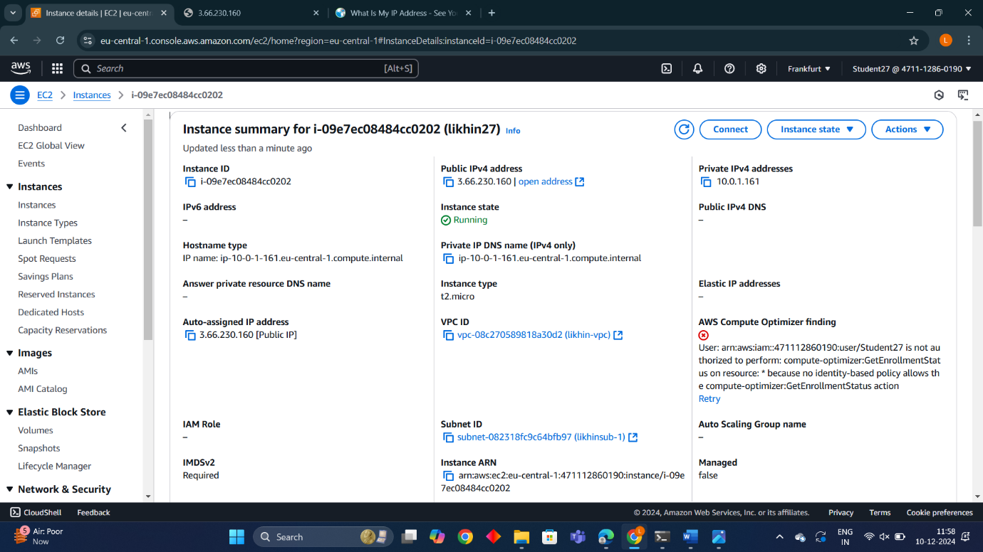

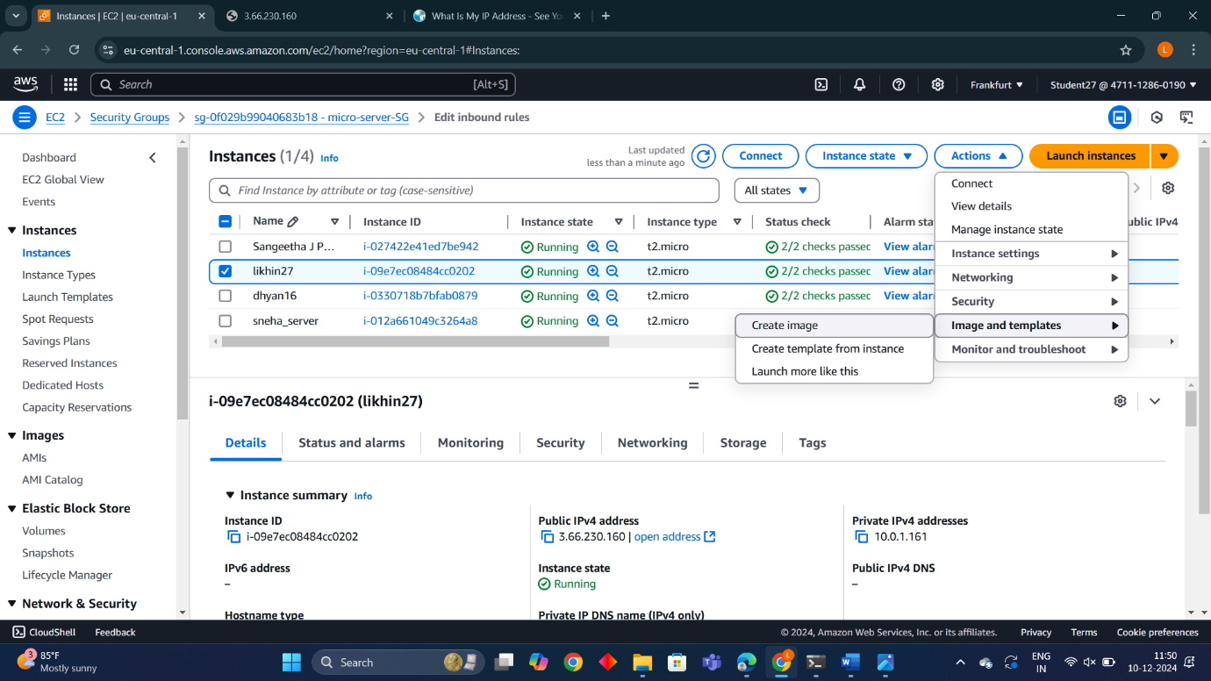

* Created AMI image as likhin27-backup

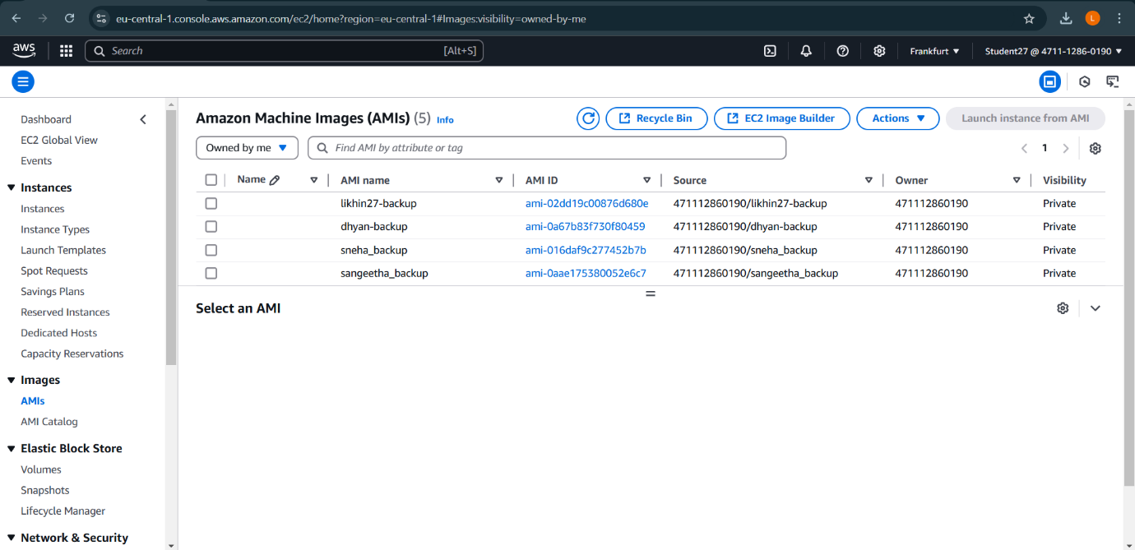

After launching the backup server :

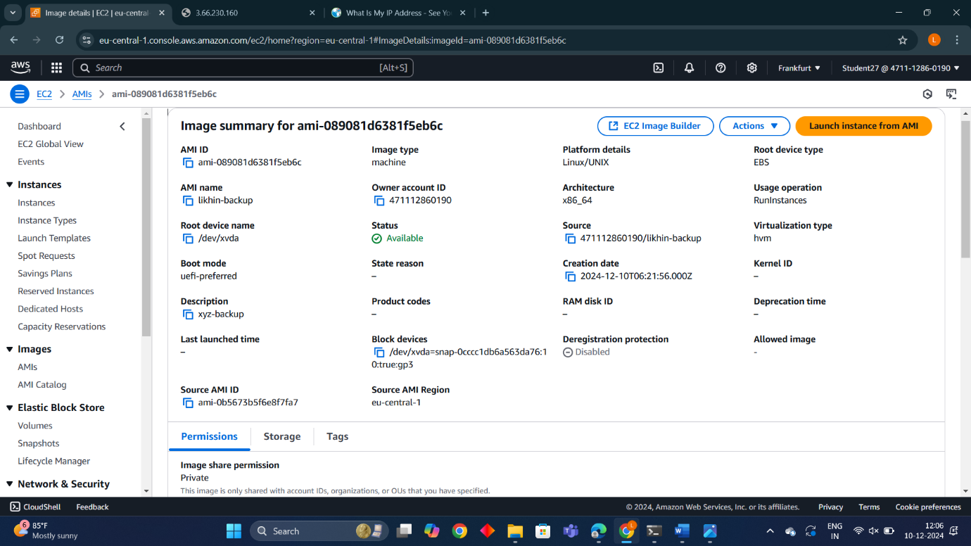

Final Result:

